***Data Description:***

This option focuses around an application that manages and processes a graph of bibliographic data derived from the DBLP Computer Science bibliography:

<http://dblp.uni-trier.de/>

We will actually be using a graph (nodes & links) form of the data, from:

<https://web.archive.org/web/20170721110641/https://kdl.cs.umass.edu/display/public/DBLP>

***Queries:***

1. Co-author count: Which publication has the most co-authors? Give full information about the paper, including title, authors and venue.

2. Recursive co-authors: How many Level 3 co-authors does Michael Stonebraker have? How many does David DeWitt have? (See below for definition.)

3. Co-author distance: At what level is Moshe Vardi from Michael J. Franklin?

4. Most authors: Which proceedings in 2010 had the most distinct authors across all papers?

5. Triangles: Which author participates in the most triangles? (See below for definition,)

6. Connectivity: Is the DBPL graph connected? (That is, is there a path between any two objects?)

**DBLP Data Details**

*Co-author Level*: For person P, Level 1 co-authors are direct co-authors of P (same publication). Level 2 co-authors are co-authors of Level 1 co-authors who aren’t themselves Level 1 co-authors. Level 3 co-authors are co-authors of Level 2 who are neither Level 1 nor Level 2.

*Triangles*: A triangle is a situation where there are two co-authors of person P who are also co-authors themselves.

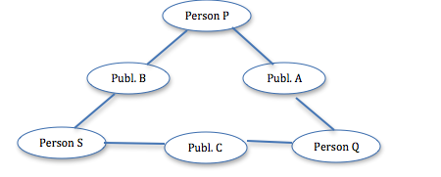

Note: P, Q & S and A, B & C should be distinct objects.